Judo Technique Clinic
by Kosei Inoue – World and Olympic Champion

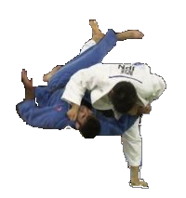
Location: Steveston Community Center,
indoor tennis courts,
4111 Moncton Street, Richmond, BC.
Date: Sunday, November 28, 2010
Time: 9:30 AM – 12:00 AM –Tachi Waza
1:30 PM – 4:00 PM – Ne Waza
Cost: $50 for participants, $10 for spectators.
Please – no video taping
Bring your own lunch or visit one of the many nearby restaurants.
Hosted by the Steveston Judo Club
===============================================================
Registration Form: Mail by Nov 25,2010
All participants MUST be at least 15 yrs of age.
Name: | Club: | Phone | email
Cost: $50 for clinic participants, $10 for spectators. No video taping.
Please mail completed registration form and fees to (Cheques payable to the Steveston Judo Club),
Steveston Judo Club
c/o Alan Sakai,
11551 Kestrel Drive,
Richmond, BC, V7E 4E3
Inquiries: phone (604) 271-0037 fax: (604) 718-8096 email: asakai@telus.net

