OSU Judo Club
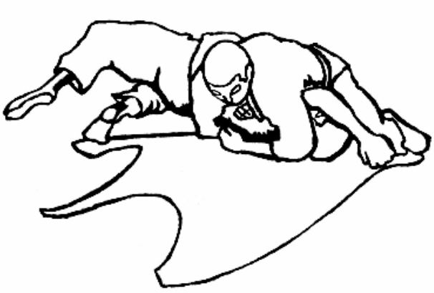
(Judo Club C.O. Sport Clubs and Intramurals)
211 Dixon Rec. Center
Oregon State University
Corvallis, OR 97331

2012 Corvallis Judo Spring Tournament
Saturday, May 26th, 2012, 9:00 AM
Tournament Director: Joshua Baur
Head Referee: Tim Reynolds

Senior Competitors Only
Entry fee $15 at the door, $5 for entry in 2nd division higher than one’s current rank
Weigh-Ins 9:00 AM - 10:30 AM
Team Competition starts at 11:00 AM
Individual Competition begins after Team Competition
(Seeding occurs during Team Competition)

USJA Sanctioned: Valid USJA, USJF, USJI membership required by referees and competitors,
as well as insurance.

Contact Information (Tournament Director):
Josh Bauer: joshua.baur@oregonstate.edu

Weight Divisions
Men
<161 lb, <179 lb, <200 lb, 200+ lb
Women
<126 lb, <139 lb, 139+ lb
All weight division categories are subject to change. The weight divisions will be determined upon receipt of all entries.

Belt Divisions
Novice (White Belts)
Intermediate
Sankyu and Higher
All contestants must compete in their own rank and weight division prior to competing in another higher division. Only Senior Brown l kyu may compete in the Black Belt Division.

Eligibility
This tournament is open to all male and female contestants registered and in good standing with the United States Judo Federation (USJF), United States Judo, Inc. (USJI), or the United States Judo Association (USJA), and must be eighteen years old as of May 26th 2012, or sixteen years old as of May 26th, 2012 and have parental and sensei consent.
All contestants must present their valid USJF, USJI, or USJA membership card at the time of registration. Any contestant unable to present their valid registration card will be required to purchase a new or renew their current membership prior to acceptance of the entry form for this tournament.

Team Competition
Five members per club.
If a team consists of less than five, it loses the corresponding points (1 pt/member).
Each competitor competes against his/her counterpart based on weight (open belt).
Decisions are made based on points.

Tournament Rules
Current International Judo Federation (UF) contest rules with the following modifications:
Shime-waza (choking techniques) will be allowed for all.
Kansetsu-waza (joint lock techniques) will be allowed for Brown and Black belts only.
Pre-1994 UF contest rules regarding safety zone and out of bounds area.
Golden Score time limit is 2 minutes. First score wins match. Hantei decision will be called if tie remains.
Additional changes or modifications may be made to ensure the safety of participants.
Competition type will be determined by the number of competitors in each division. If there are five or less competitors round robin competition will be used. If there are more than five competitors in a division double elimination will be used.

Awards
First, second and third place awards will be given in each division. Team trophies and individual ribbons will be awarded to the first place team.
Awards will be presented at the end of the tournament. Contestants will be called to trophy presentation.

Tournament location
Oregon State University
Dixon Recreation Center (Main, West Entrance - Registration) (Upper Basketball Court - Tournament)
425 SW 26th Street Corvallis, OR 97331

Directions to Dixon Rec Center (from I-5):
1. Take exit 228 for OR-34 toward Corvallis (9.6 mi).
2. Turn left at Corvallis-Newport Hwy/OR-34-BYP (13 mi).
3. Turn right at SW 15th St (0.3 mi).
4. Turn left at SW Washington Way (0.3 mi).
5. Turn right at SW 26th St (450 ft).
6. Dixon Rec Center is on your right side.

