2018 Inland Empire Judo Classic

Spokane, Washington
Saturday, May 26, 2018

Spokane Convention Center
Ballroom 100BC
334 W Spokane Falls Blvd
Spokane, WA 99201

USJF Sanction: # 18-05-05

Tournament Point of Contact
Leigh Yamada, 509-844-7296
pacificjudoacademy@comcast.net

2018 Inland Empire Judo Classic
USJF Sanction: # 18-05-05

Tournament Directors: Leigh Yamada & Mike Marcella

Head Referee: Brian Toth

Tournament Date: Saturday, May 26, 2018
Competition Starts: 9:30 am

Tournament Site: Spokane Convention Center, Ballroom 100BC
334 W Spokane Falls Blvd
Spokane, WA 99201

Tournament Type: NEW: True Double Elimination for 6 or more contestants.
Round Robin for 5 or less.

NWJY Meeting: NOTE NEW TIME/LOCATION: Friday, May 25th at the Doubletree Hotel, with the Board of Examiners meeting beginning at 6 pm. Yudanshakai meeting immediately after

Eligibility: USJF, USA Judo, USJA, or Judo Canada cards will be checked at registration. USJF membership applications will be available for $70.00, plus $2.00 handling fee.

Registration Info: Entry Fee $35, Second entry $20. Make checks payable to Pacific Judo Academy
Late entry $70
NEW: Online registration by Wednesday, May 23rd at
https://goo.gl/forms/UbiMZoKk7FuaG9Vo2

Weigh In: ONLY: Friday, May 25th, 5:00-8:30pm @ Doubletree Hotel

Note: Brackets and match cards will be completed Friday night based on registration and Friday night weigh in. Divisions may be adjusted and/or combined as required based on actual entries. Coaches, instructors, and parents will have an opportunity to review the categories and confirm their athlete’s suitability for participation.

2018 IJF rules with the following modifications:
- Shime-waza rule: Shime-waza allowed for 13 years and older only.
- Kansetsu-waza rule: Kansetsu-waza allowed in 15 & 16 year old, Brown & Black and Masters only. No arm bars in any novice division.
- Blue & White judo gi are required for all senior divisions. Optional for Juniors, but encouraged. Each competitor must supply their own white and blue obi.
- 2014 Judo gi rule (increased sleeve length and top cross-over) for all divisions will be implemented. IJF approved judo gis are not required.
- Current IJF medical rules apply to all divisions.
- Match time for juniors will be 3 minutes. Match time for all senior divisions will be 4 minutes
Match time will be 3 minutes for masters.
- There may be co-ed competition for males & females 10 years of age and under depending upon the number of entries.
- If a player moves up a division by their own choice, they will be subjected to the rules of that division.
- Weight divisions may be modified at the tournament director’s discretion for the safety of the participants.

Junior Boys & Girls
M/F Ages 5-6 Novice | Light | Medium | Heavy
M/F Ages 5-6 | Light | Medium | Heavy
M/F Ages 7-8 Novice | Light | Medium | Heavy
M/F Ages 7-8 | Light | Medium | Heavy
M/F Ages 9-10 Novice | Light | Medium | Heavy
M/F Ages 9-10 | Light | Medium | Heavy
M/F Ages 11-12 | Light | Medium | Heavy
M/F Ages 13-14 | Light | Medium | Heavy
M/F Ages 15-16 | Light | Medium | Heavy

Novice Division is Yellow and below and will be created based on the number of entries.

Senior Men & Women
M/F Novice | Light | Medium | Heavy
M/F Brown/Black | Light | Medium | Heavy
M/F Masters (35+) | Light | Medium | Heavy

Master’s Division ONLY Special Ruleset

Leg grab techniques such as Kata Guruma, Te Guruma, Morote Gari, Sukui Nage, Kibisu Gaeshi will be allowed for scoring purposes and will not be penalized. Techniques banned for safety reasons (i.e. Kani Basami, Kawazu Gake, etc.) will still be direct Hansoku Make.

2018 Inland Empire Judo Classic
USJF Sanction: # 18-05-05

Name
(Please print)

Address

Phone ( ) Email

Date of Birth Age Gender

Weight lbs Division Rank/Belt Color

Membership Card # Expiration Affiliation

Judo Club Instructor

Second Entry

Division

Instructor’s Signature Parent/Guardian Signature

CERTIFICATE REGARDING NON-BLACK BELT CONTESTANTS

I, , a Judo instructor, who has been awarded the Judo rank of Shodan or higher, recognized by a National Judo Federation, hereby certify that although not having been awarded the Judo rank of Shodan or higher, is of sufficient aptitude and skill in Judo to compete in this tournament.

Signature of Black Belt Judo Instructor Date

If assistance/accommodation is needed (please check off appropriate category):
□Vision Loss/Blindness □Hearing Loss/Deafness

Type of assistance/accommodation requested or name of person assisting:

The DoubleTree by Hilton Spokane City Center
Welcomes
The 2018 Inland Empire Judo Classic!

We are pleased to offer a special rate just for you!
$139.00 + tax up to 4 people
Rate includes a full hot breakfast buffet each day up to 4 people and 50% off overnight self-parking

To book a reservation and receive the special discounted rate please visit the Personalized Group Webpage found at http://group.doubletree.com/InlandEmpireJudo2018 or call the Hotel room reservation department at our toll-free number 1-800-757-6131 or 1-509-744-2363, and request the group rate for Pacific Judo Academy. To receive this rate, rooms must be booked by Wednesday, April 25, 2018.
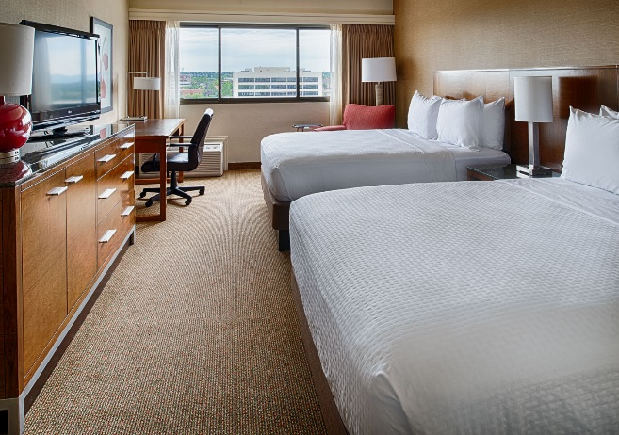
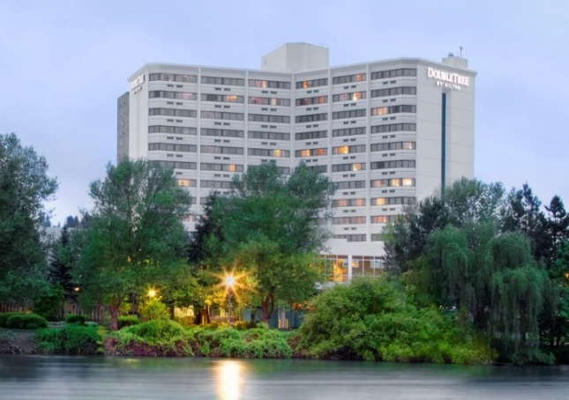

In the heart of downtown, the DoubleTree by Hilton Hotel Spokane City Center puts you right in the middle of the action. Connected by sky-bridge to the Spokane Convention Center, this stylish and comfortable hotel is within walking distance of a vibrant district of shops and restaurants. Get a great night’s sleep on the comfortable bed. Indulge in a delicious signature DoubleTree chocolate chip cookie, our special welcoming gift to you when you check in at this Spokane hotel.

