2019 Inland Empire Judo Classic

Spokane, Washington
Saturday, May 25, 2019

Spokane Convention Center
Ballroom 100BC
334 W Spokane Falls Blvd
Spokane, WA 99201

USJF Sanction: # 19-05-06

Tournament Point of Contact
Leigh Yamada, 509-844-7296
pacificjudoacademy@comcast.net
2019 Inland Empire Judo Classic
USJF Sanction: # 19-05-06

Tournament Directors: Leigh Yamada & Mike Marcella

Head Referee: Patrick Lo

Tournament Date: Saturday, May 25, 2019
Competition Starts: 9:30 am

Tournament Site: Spokane Convention Center, Ballroom 100BC
334 W Spokane Falls Blvd
Spokane, WA 99201

Tournament Type: True Double Elimination for 6 or more contestants.
Round Robin for 5 or less.

NWJY Meeting: Friday, May 24th at the Doubletree Hotel, with the Board of Examiners meeting beginning at 6 pm. Yudanshakai meeting immediately after.

Eligibility: Must have current USJF, USA Judo, USJA, or Judo Canada cards

Registration Info: Entry Fee $35, Second entry $20. Make checks payable to Pacific Judo Academy
Online registration by Wednesday, May 22, at
https://goo.gl/forms/UbiMZoKk7FuaG9Vo2

Weigh In: NEW: Between May 22-23, each dojo will weigh in their own competitors and email a roster with official weights to pacificjudoacademy@comcast.net by midnight February 23rd.
One person from each club will turn in all entry form, waiver, copy of membership card, along with payment on Friday, May 24th at the Doubletree. Please use the attached spreadsheet.

2019 IJF rules with the following modifications:
- Shime-waza rule: Shime-waza allowed for 13 years and older only.
- Kansetsu-waza rule: Kansetsu-waza allowed in Brown & Black and Masters only.
- Blue & White judo gi are required for all senior divisions. Optional for Juniors, but encouraged. Each competitor must supply their own white and blue obi.
- 2014 Judo gi rule (increased sleeve length and top cross-over) for all divisions will be implemented. IJF approved judo gis are not required.
- Current IJF medical rules apply to all divisions.
- Match time for juniors will be 3 minutes. Match time for all senior divisions will be 4 minutes
Match time will be 3 minutes for masters.
- There may be co-ed competition for males & females 10 years of age and under depending upon the number of entries.
- If a player moves up a division by their own choice, they will be subjected to the rules of that division.
- Weight divisions may be modified at the tournament director’s discretion for the safety of the participants.

Junior Boys & Girls
M/F Ages 5-6 Novice | Light | Medium | Heavy
M/F Ages 5-6 | Light | Medium | Heavy
M/F Ages 7-8 Novice | Light | Medium | Heavy
M/F Ages 7-8 | Light | Medium | Heavy
M/F Ages 9-10 Novice | Light | Medium | Heavy
M/F Ages 9-10 | Light | Medium | Heavy
M/F Ages 11-12 | Light | Medium | Heavy
M/F Ages 13-14 | Light | Medium | Heavy
M/F Ages 15-16 | Light | Medium | Heavy

Novice Division is Yellow and below and will be created based on the number of entries.

Senior Men & Women
M/F Novice | Light | Medium | Heavy
M/F Brown/Black | Light | Medium | Heavy
M/F Masters (35+) | Light | Medium | Heavy

Master’s Division ONLY Special Ruleset

Leg grab techniques such as Kata Guruma, Te Guruma, Morote Gari, Sukui Nage, Kibisu Gaeshi will be allowed for scoring purposes and will not be penalized. Techniques banned for safety reasons (i.e. Kani Basami, Kawazu Gake, etc.) will still be direct Hansoku Make.

2019 Inland Empire Judo Classic
USJF Sanction: # 19-05-06

Name
(Please print)

Address

Phone ( ) Email

Date of Birth Age Gender

Weight lbs Division Rank/Belt Color

Membership Card # Expiration Affiliation

Judo Club Instructor

Second Entry

Division

Instructor’s Signature Parent/Guardian Signature

CERTIFICATE REGARDING NON-BLACK BELT CONTESTANTS

I, , a Judo instructor, who has been awarded the Judo rank of Shodan or higher, recognized by a National Judo Federation, hereby certify that although not having been awarded the Judo rank of Shodan or higher, is of sufficient aptitude and skill in Judo to compete in this tournament.

Signature of Black Belt Judo Instructor Date

If assistance/accommodation is needed (please check off appropriate category):
□Vision Loss/Blindness □Hearing Loss/Deafness

Type of assistance/accommodation requested or name of person assisting:

The DoubleTree by Hilton Spokane City Center
Welcomes
The 2019 Inland Empire Judo Classic!

We are pleased to offer a special rate just for you!
$143.00 + tax up to 4 people
Rate includes a full hot breakfast buffet each day up to 4 people and 50% off overnight self-parking

To book a reservation and receive the special discounted rate please visit the Personalized Group Webpage found at http://doubletree.hilton.com/en/dt/groups/personalized/S/SPCC-DT-IEJ-20190524/index.jhtml or call the Hotel room reservation department at our toll-free number 1-800-757-6131 or 1-509-744-2363, and request the group rate for Inland Empire Judo Classic. To receive this rate, rooms must be booked by Wednesday, April 24, 2019.
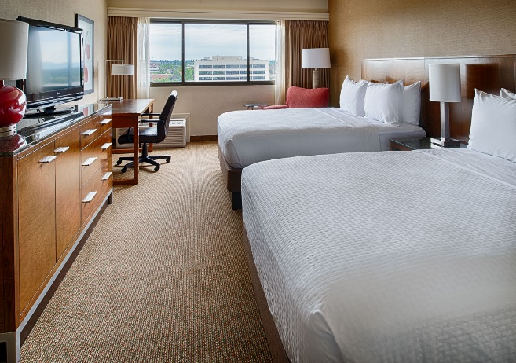
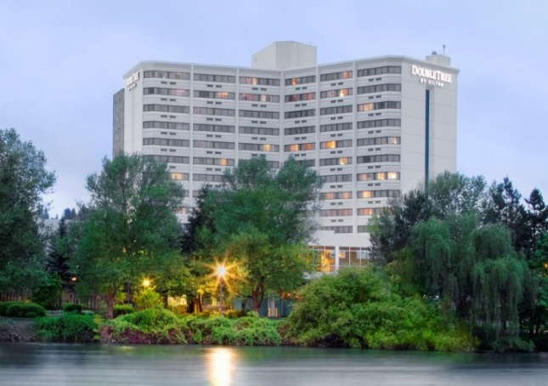

In the heart of downtown, the DoubleTree by Hilton Hotel Spokane City Center puts you right in the middle of the action. Connected by sky-bridge to the Spokane Convention Center, this stylish and comfortable hotel is within walking distance of a vibrant district of shops and restaurants. Get a great night’s sleep on the comfortable bed. Indulge in a delicious signature DoubleTree chocolate chip cookie, our special welcoming gift to you when you check in at this Spokane hotel.

